A URL Shorterner
by
TAN Xingzhi
3036532736

Dissertation midterm report
2025/2026 Sem 2

Master of Engineering
In
EEE
of
The University of Hong Kong

CONTENTS
1. Project Overview 3
1.1 Background 3
1.2 Project objectives 4
1.3 Original research question 4
2. Progress Update 5
2.1 User Authentication & Account Management 5
2.2 URL Shortening Core Engine 6
2.3 Expiration & Lifecycle Management 7
2.4 Redirection & Click Analytics 7
2.5 User Dashboard & Link Management 8
2.6 Detailed Statistics View 8
2.7 QR Code Generation 8
2.8 Administrative Panel 8
2.9 Cross-Database Compatibility 9
2.10 Frontend User Interface 9
2.11 Deployment Readiness 9
3. Methodology & Implementation 10
3.1 Database Design 10
3.2 Short Code Generation & Validation Algorithm 12
3.3 QR Code Integration 15
4. Critical Evaluation 16
4.1 Security Weaknesses 16
4.2 Usability and Functional Gaps 18
4.3 Summary 19
5. Conclusion & Next Steps 20
5.1 Conclusion 20
5.2 Next Steps 20
5.3 Anticipated Final Deliverables 23

Project Overview

Background
URL shorteners are online services or web tools that convert lengthy Uniform Resource Locators (URLs) into short, memorable URLs. This reduces the complexity of remembering and typing for users and facilitates sharing in contexts with character limits, such as social media and SMS. The core function of shortened links is to reduce the number of characters in the original URL to improve dissemination efficiency; its principles include URL mapping mechanisms and HTTP redirection technology.
The core value of shortened link services lies not only in improving link readability and user experience but also in their powerful data analysis and click tracking capabilities—providing data such as click volume, user geographic location, device type, and conversion rates to help businesses optimize marketing campaigns and analyse user behaviour. It has become deeply integrated into the digital business ecosystem.
The earliest URL shortening service can be traced back to TinyURL, launched in 2002 and developed by Kevin Gilbertson. Its predecessor dates to 2001. TinyURL's creation influenced the creation of at least 100 subsequent URL shortening services[1]. According to The New York Times, TinyURL, founded in 2002 by a unicycle enthusiast named Kevin Gilbertson, was the most popular URL shortening service. TinyURL later experienced rapid growth, storing approximately 293 million URLs in its database.
Modern enterprise-level short link services have long surpassed basic redirects, offering data tracking capabilities such as recording clicks, regions, devices, and source channels. They can generate dynamic links with UTM parameters; they also feature brand customization, allowing users to replace public domains with their own domains (e.g., s.companyname.com/event), enhancing company credibility and exposure, and increasing click-through rates by an average of 34%; in terms of security, they can block phishing/spam websites and prevent links from being blocked; they support link expiration dates, password access, and single-use validity; and they have dynamic adjustment capabilities—if printed materials have already been sent and the original link is found to be invalid, the target URL pointed to by the short link can be modified in the backend, eliminating the need to reprint materials[2].

Project objectives
Build a fully functional short link generation and management platform, providing features such as custom short codes, access statistics, expiration control, and QR code generation, while also having the ability to analyze multiple types of click data.
- Implements user registration, login, and password reset authentication functions.
- Supports shortening long URLs to system-generated or user-defined short codes.
- Records detailed data for each short link access (IP, User-Agent, Referer).
- Provides flexible expiration time settings (1 day/7 days/30 days/permanent) and custom expiration conditions.
- Generates a QR code for each short link and supports downloading.
- Supports user management of their generated short codes. Provides short link access data analysis and visualization, generating analysis reports for user-generated short code click data.
- User-friendly interface

Original research question
- How to design a lightweight, efficient, secure, and stable URL shortener to achieve fast compression and accurate redirection of long URLs, while addressing the core pain points of traditional shorteners such as redirection delays and broken links?
- Regarding the uniqueness conflicts and data security issues during URL shortening, what encoding algorithms and storage schemes should be adopted to ensure the uniqueness of the shortened URL while protecting user privacy and link security?
- How to add practical extended functions to the URL shortener (such as access statistics, expiration management, and custom shortening codes) to improve product usability and meet the actual needs of individuals and small teams?

Progress Update

2.1 User Authentication & Account Management
- User Registration: New users can create an account by providing a unique username, email, and password (minimum 6 characters). Passwords are securely hashed using generate_password_hash.
- User Login: Authentication supports both username and email as identifiers. Session management is implemented using Flask's signed cookies.
- Password Reset Flow: A complete "forgot password" workflow is in place. A UUID-based reset token with a 1-hour expiry is generated and stored in the database. The reset link is displayed in the server console (simulating email delivery for demonstration purposes).
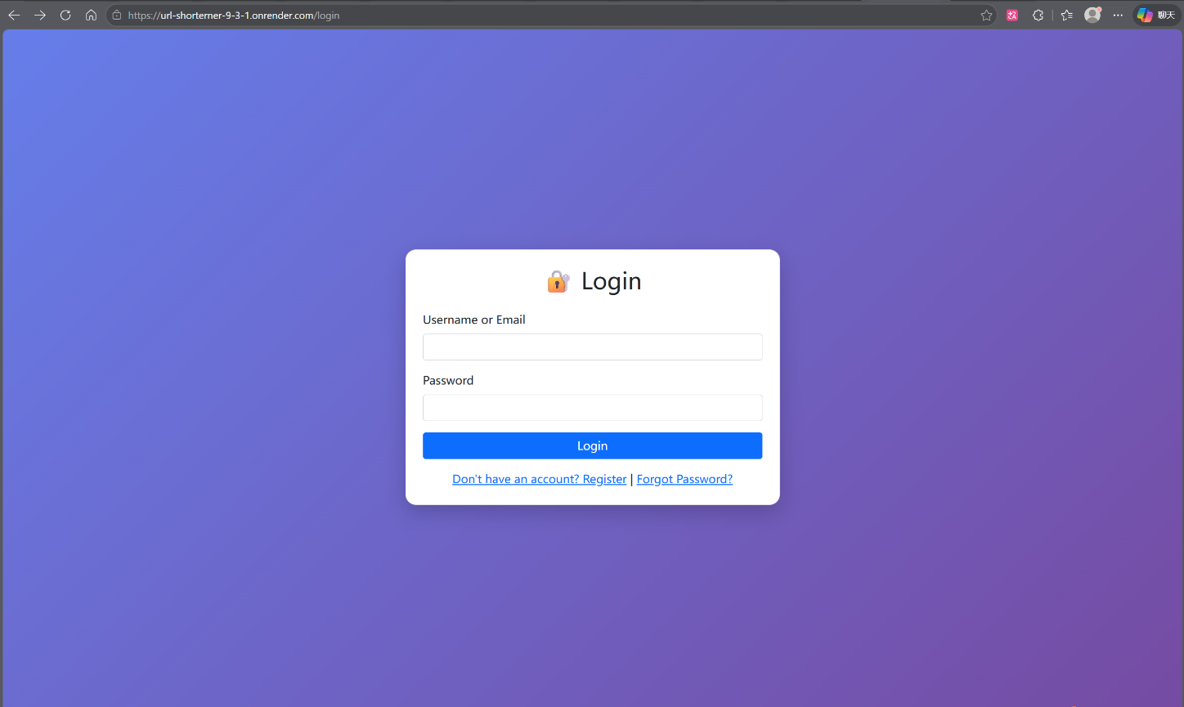
- Logout: Session clearance and redirection to the login page.

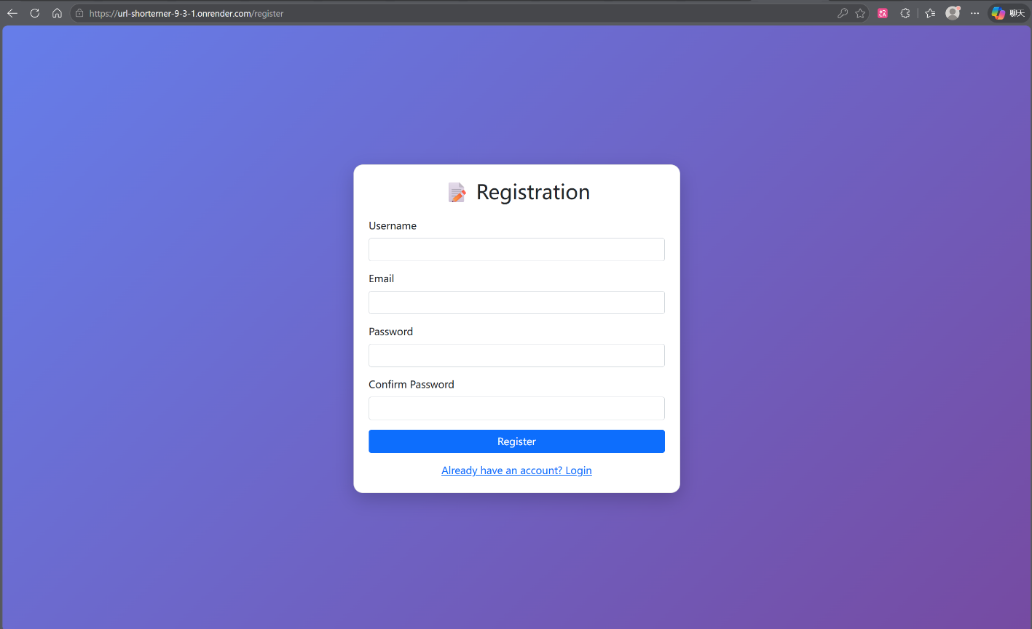

2.2 URL Shortening Core Engine
- Long URL Submission: Users submit a target URL. The system automatically prepends https:// if no scheme is provided.
- Random Short Code Generation: When no custom code is requested, the system generates a 6-character alphanumeric code using a cryptographically secure random selection (random.choice). The generator checks for collisions and reserved words, retrying up to 10 times before failing gracefully.
- Custom Short Code Support: Users may specify a vanity short code. The system enforces strict validation rules:
- Length: 3–20 characters.
- Allowed characters: a-z, A-Z, 0-9, _, -.
- No leading/trailing hyphens or consecutive hyphens.
- Prohibited use of reserved system paths (e.g., admin, api, login).
- Duplicate Prevention: The system verifies the uniqueness of any custom code against the database before insertion.

2.3 Expiration & Lifecycle Management
- Configurable Expiry: Users may select an expiration period for each shortened link: 1 day, 7 days, 30 days, or "Permanent".
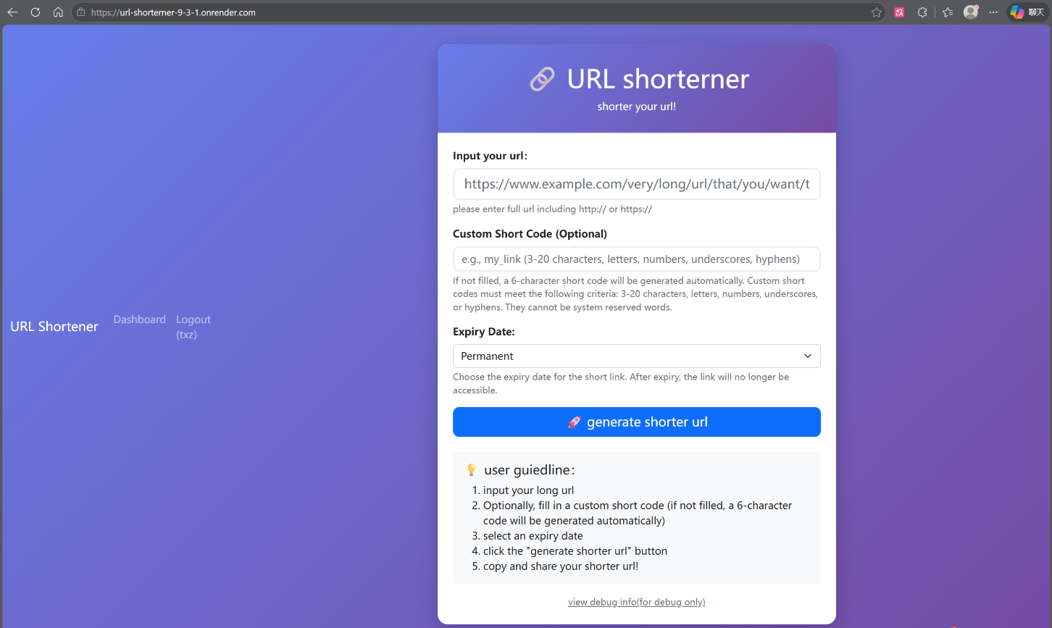
- Expiry Enforcement: During redirection, the system compares the current timestamp against the stored expires_at value. Expired links return an HTTP 410 (Gone) error page.

2.4 Redirection & Click Analytics
- HTTP 302 Redirect: Accessing a valid short code (/<short_code>) seamlessly redirects the user's browser to the original long URL.
- Real-time Click Counter: Each redirect increments the click_count field in the url_mappings table.
- Detailed Click Logging: The following metadata is recorded in the clicks table for every access:
- IP Address: Extracted from X-Forwarded-For header (to support proxy deployments like Render) or request.remote_addr.
- User-Agent: The full browser/client identifier.
- Referer: The HTTP referrer, if available.
- Timestamp: Exact date and time of access.

2.5 User Dashboard & Link Management
- Personal Link Inventory: Authenticated users can view all URLs they have created via /dashboard. The table displays the short code, original URL (truncated), click count, creation date, expiration date, and current status (Active/Expired).
- Client-side Time Localization: UTC timestamps from the database are converted to the user's local time zone via JavaScript, improving readability.
- Link Deletion: Users may delete any link they own. The action cascades to remove associated click logs and the corresponding QR code image file.
- Lifecycle Extension: For links with a set expiration date, users can extend the validity by an additional 30 days with a single click (/extend/<short_code>).

2.6 Detailed Statistics View
- Per-Link Analytics: Owners (and administrators) can access a dedicated statistics page (/stats/<short_code>) that lists every individual click event in reverse chronological order, including IP, User-Agent, timestamp, and referrer.

2.7 QR Code Generation
- Automatic Generation: Upon successful creation of a short URL, a QR code encoding the short link is generated using the qrcode library and saved as a PNG file in static/qrcodes/.
- Frontend Integration: The success page displays the QR code image (if generation succeeded) and provides a download button for users to save the image locally.

2.8 Administrative Panel
- Admin Authentication: Access to /admin is restricted to the user with username admin (hardcoded for the prototype phase).
- Global Statistics Overview: The admin dashboard displays:
- Total number of shortened URLs.
- Number of custom short codes.
- Aggregate click count across all links.
- Recent Links Monitoring: A table listing the 20 most recently created links, with options to delete any link or view its statistics.
- User Management: A complete list of registered users with the ability for the admin to delete any user account (excluding themselves). Deleting a user cascades to remove all their associated URLs.

2.9 Cross-Database Compatibility
- Dual Database Support: The application seamlessly operates with either SQLite (for local development) or PostgreSQL (for production deployment), toggled by the presence of the DATABASE_URL environment variable.
- Automated Schema Migration: The init_db() function detects the active database engine and automatically creates tables. Additionally, it checks for the existence of required columns and adds any missing columns (e.g., is_custom, click_count, expires_at) to ensure compatibility with older schema versions.

2.10 Frontend User Interface
- Responsive Design: All HTML templates (index.html, login.html, register.html, dashboard.html, link_stats.html, admin_dashboard.html, forgot_password.html, reset_password.html) are styled with Bootstrap 5, ensuring a consistent and mobile-friendly user experience.
- Social Sharing & Clipboard Integration: The success page includes buttons to copy the short URL to the clipboard and to share the link directly via Twitter, WhatsApp, or Email using pre-filled message templates.
- Error & Success Handling: Custom, visually distinct HTML pages are returned for errors (e.g., invalid custom code, link not found, expired link) and successful URL creation, providing clear feedback and navigation options.

2.11 Deployment Readiness
- Gunicorn Configuration: A gunicorn_config.py file is prepared for production WSGI serving.
- Dependency Management: requirements.txt lists all necessary Python packages.
- Environment Variable Configuration: The application is configured to read PORT, SECRET_KEY, and DATABASE_URL from the environment, aligning with best practices for cloud platforms like Render.

Methodology & Implementation

3.1 Database Design
The application employs a relational database model with three primary tables: users, url_mappings, and clicks. The system supports both SQLite (for local development) and PostgreSQL (for production deployment) through a unified connection factory that toggles SQL syntax and placeholder styles (? vs. %s) based on the DATABASE_URL environment variable.
- Users Table
The users table stores account credentials and password recovery tokens. Passwords are never stored in plaintext; instead, a salted hash generated by Werkzeug's generate_password_hash (using the scrypt algorithm by default) is persisted.
Column | Type | Description
id | SERIAL / INTEGER | Auto-incrementing unique identifier.
username | VARCHAR(100) / TEXT | User's chosen display name.
email | VARCHAR(255) / TEXT | Email address for password recovery.
password_hash | VARCHAR(255) / TEXT | Hashed password using Werkzeug security utilities.
create_at | TIMESTAMP | Account registration timestamp.
reset_token | VARCHAR(36) / TEXT | UUID v4 token for password reset requests.
reset_token_expiry | TIMESTAMP | Expiration timestamp for the reset token (valid for 1 hour).
- URL Mappings Table
The url_mappings table is the core of the shortening service. Each row represents a single shortened link and contains both the mapping information and metadata for lifecycle management.
Column | Type | Description
id | SERIAL / INTEGER | Auto-incrementing record ID.
long_url | TEXT | The original, full-length destination URL.
short_code | VARCHAR(50) / TEXT | The unique identifier used in the shortened path (e.g., abc123).
is_custom | BOOLEAN | Indicates whether the short_code was user-defined.
created_at | TIMESTAMP | Creation timestamp of the mapping.
click_count | INTEGER | Cumulative number of times the short link has been accessed.
user_id | INTEGER | The owner of the link. Set to NULL if the user is deleted, preserving link data.
expires_at | TIMESTAMP | The date and time after which the link becomes invalid. NULL indicates no expiration.
A unique index on short_code is enforced by the UNIQUE constraint, ensuring O(log n) lookup performance during redirection. The user_id foreign key establishes referential integrity and allows cascading operations (e.g., retrieving all links belonging to a specific user).
- Clicks Table
The clicks table logs detailed metadata for every access event. This normalized schema separates transactional analytics from the primary mapping table, preventing write contention on url_mappings and enabling granular analysis without impacting redirection latency.
Column | Type | Description
id | SERIAL / INTEGER | Auto-incrementing log entry ID.
short_code | VARCHAR(50) / TEXT | The short code that was accessed.
ip_address | VARCHAR(45) / TEXT | Client IP address (supports IPv6 length).
user_agent | TEXT | The User-Agent header string from the client.
accessed_at | TIMESTAMP | Precise time of the click event.
referer | TEXT | The HTTP Referer header, indicating the source of the click.
A non-unique index is created on short_code to accelerate queries that retrieve click history for a specific link (e.g., the /stats page). The ON DELETE CASCADE clause ensures that click logs are automatically purged when the associated short link is removed, maintaining data consistency.
- Schema Migration & Compatibility
To support iterative development and deployment across different database engines, the init_db() function implements a self-healing migration mechanism. It first executes the standard CREATE TABLE IF NOT EXISTS statements for all three tables. Subsequently, it queries the database's information schema (PostgreSQL) or PRAGMA table_info (SQLite) to detect missing columns. If a column such as is_custom or expires_at is absent from an existing database, an ALTER TABLE statement is dynamically issued to add the column. This approach ensures that the application can be deployed over an older database version without manual migration scripts.

3.2 Short Code Generation & Validation Algorithm
The system provides two pathways for obtaining a short code: automatic random generation and user-specified custom codes. Both pathways are governed by a rigorous validation framework to ensure URL safety and system integrity.
- Automatic Random Code Generation
When a user does not provide a custom code, the system generates a 6-character alphanumeric string. The generation algorithm is defined as follows:
import random
import string
def generate_short_code(length=6):
characters = string.ascii_letters + string.digits
return ''.join(random.choice(characters) for _ in range(length))
The character set consists of 26 lowercase letters, 26 uppercase letters, and 10 digits, yielding a total of 62 possible characters. A 6-character code therefore provides a theoretical keyspace of 62⁶ ≈ 5.68 × 10¹⁰ (approximately 56.8 billion) unique combinations[3].
Collision Handling: Before inserting a generated code, the system performs a database lookup to verify uniqueness. If a collision occurs (the code already exists), the generator retries up to 10 times. The probability of a collision within a modest number of existing entries is low due to the large keyspace; however, the retry loop provides a robust fallback. If all 10 attempts result in collisions, the system returns an error, prompting the user to try again or use a custom code.
Reserved Word Filtering: In addition to database uniqueness, generated codes are checked against a predefined list of RESERVED_WORDS. This list includes route endpoints (e.g., login, admin, api, dashboard) and functional paths that could conflict with the application's URL structure. Any generated code that matches a reserved word (case-insensitive) is discarded, and a new code is generated. This preemptive filtering prevents routing ambiguities and potential security bypasses.
- Custom Code Validation
User-submitted custom codes are subject to a comprehensive validation function, validate_custom_code(code), which enforces the following rules:

Rule | Implementation | Rationale
Length between 3 and 20 characters | if len(code) < 3 or len(code) > 20 | Prevents excessively short (easy to brute-force) or long (defeating the purpose of shortening) codes.
Allowed character set: a-zA-Z0-9_- | Regular expression ^[a-zA-Z0-9_-]+$ | Ensures URL safety and avoids percent-encoding issues in most contexts.
No leading or trailing hyphens | if code.startswith('-') or code.endswith('-') | Prevents ambiguity in domain name concatenation and improves readability.
No consecutive hyphens | if '--' in code | Prevents visual confusion and potential security issues related to IDN homograph attacks.
Not a reserved word | if code.lower() in RESERVED_WORDS | Protects application routes from being hijacked or overridden.
If all validations pass and the custom code is not already present in the url_mappings table, it is accepted and stored with is_custom = True. Otherwise, a descriptive error message is returned to the user, indicating which specific rule was violated.
- Expiration Logic
The system supports four expiration options selectable by the user: 1d (1 day), 7d (7 days), 30d (30 days), and forever. The corresponding timedelta objects are stored in the EXPIRY_OPTIONS dictionary. When a link is created, the expires_at column is set to datetime.now() + delta for the finite options, or NULL for permanent links.

During redirection (@app.route('/<short_code>')), the system retrieves the expires_at value. If it is not NULL and the current time is greater than expires_at, the system returns an HTTP 410 (Gone) error page. This check is performed before incrementing the click count or logging the access, ensuring that expired links consume no analytics resources.
- Redirection and Click Logging Workflow
The redirection process is optimized for minimal latency while capturing comprehensive analytics. The sequence of operations is as follows:
- Lookup: The short_code is used to query url_mappings. The unique index ensures a fast point lookup.
- Expiry Check: If the link is expired, abort with a 410 error.
- Click Count Increment: An UPDATE url_mappings SET click_count = click_count + 1 is executed.
- Metadata Extraction: The client IP is extracted from the X-Forwarded-For header (if present) to accommodate reverse proxy setups (e.g., Render, Nginx). The User-Agent and Referer headers are also captured.
- Log Insertion: A new row is inserted into the clicks table with the gathered metadata.
- Redirection: An HTTP 302 Found response is returned with the Location header set to the long_url.
All database operations are performed within a single request context. While this synchronous approach is sufficient for the current prototype scale, the architecture allows for future offloading of the click logging step to an asynchronous task queue (e.g., Redis Queue) to further reduce tail latency under high concurrency.

3.3 QR Code Integration
QR code generation is implemented using the qrcode library. Upon successful creation of a short link, the system asynchronously (in the same request thread) generates a PNG image encoding the full short URL. The image is saved to static/qrcodes/{short_code}.png. The success page then conditionally renders an <img> tag if the file exists. This approach decouples the generation process from the HTTP response; if file I/O fails, the user still receives a functional success page without the QR code, ensuring graceful degradation[4].

4. Critical Evaluation
This section provides an objective assessment of the current state of the project across two primary dimensions: security and usability. By identifying existing limitations and shortcomings, this evaluation establishes a clear direction for subsequent optimization efforts in the final phase of development.

4.1 Security Weaknesses
While the project implements salted password hashing using industry-standard algorithms, several notable security vulnerabilities remain unaddressed in the current prototype. These issues must be resolved before the system can be considered suitable for production deployment.
- Fragile Administrator Privilege Determination: Administrative access is currently granted solely based on a hardcoded string comparison checking whether the session username equals `admin`. This approach suffers from two fundamental flaws. First, any ordinary user who successfully registers the username `admin` would automatically inherit full administrative control over the entire system. Second, the absence of a dedicated `is_admin` flag in the database schema means that privilege escalation or delegation is impossible without modifying source code. A robust solution would involve storing administrative status as a Boolean field within the `users` table and verifying this field on each privileged request.
- Cross-Site Request Forgery (CSRF) Vulnerabilities: None of the state-changing POST requests—including link deletion, expiration extension, password reset submission, and administrative user removal—are protected by CSRF tokens. Consequently, a malicious third-party website could craft a hidden form that, when visited by an authenticated user, silently triggers an unintended action on the URL shortening service. Given that the application manages user-owned resources and sensitive account operations, the absence of CSRF protection represents a tangible security risk that could lead to unauthorized data modification or account compromise.
- Incomplete Password Reset Workflow: The password recovery mechanism currently generates a valid reset token and displays the corresponding reset link directly in the server console output. While this approach facilitates demonstration and local testing, it entirely bypasses the essential step of delivering the token to the legitimate user's verified email address. In a real-world deployment, this would render the password reset functionality unusable, forcing administrators to rely on manual intervention for account recovery. Integration with an SMTP service or a transactional email API is required to complete this feature.
- Privacy Concerns in Click Logging: The `clicks` table retains the complete, unredacted IP address and User-Agent string of every visitor who accesses a shortened link. Although this data is valuable for analytics and abuse detection, its indefinite retention in plaintext creates a potential privacy liability. Should the database be compromised, the access patterns and device fingerprints of users could be exposed. Implementing data anonymization techniques—such as IP address hashing or truncation—or establishing a data retention policy with automatic purging of aged logs would mitigate this concern.
- Lack of Rate Limiting: The current system imposes no restrictions on the frequency of requests to sensitive endpoints, including login attempts, registration submissions, and short code generation. This absence of rate limiting exposes the application to brute-force attacks targeting user credentials and to denial-of-service scenarios where a malicious actor could exhaust system resources by submitting an excessive volume of URL shortening requests. Introducing per-IP or per-account throttling would significantly enhance the system's resilience against automated abuse.

4.2 Usability and Functional Gaps
From a user experience and practical utility standpoint, the project has achieved a solid foundation of core functionality. Nevertheless, several enhancements would substantially elevate the service's value proposition and align it more closely with mature commercial offerings.
- Absence of Visual Analytics: The link statistics page currently presents click data exclusively in a tabular format, listing individual access events with their associated timestamps, IP addresses, and User-Agent strings. While this raw data is comprehensive, it fails to provide users with actionable insights at a glance. The inclusion of visualizations—such as a line chart depicting click volume over time, a geographic heatmap derived from IP geolocation, or a pie chart illustrating device and browser distribution—would enable users to interpret engagement patterns more efficiently and derive greater value from the analytics feature.
- Limited Short Code Management Capabilities**: Once a shortened link is created, users are unable to modify either the destination URL or the associated short code. If a user inadvertently enters an incorrect long URL or later wishes to update the target address without breaking existing shared links, the only available recourse is to delete the original mapping and create a new one. This operation results in the irretrievable loss of accumulated click statistics and disrupts any previously distributed short URLs. Providing an editing interface for the destination URL—and, under strict validation, the short code itself—would greatly improve operational flexibility.
- No Support for Batch Operations: The user dashboard currently permits only individual actions on links: deleting or extending them one at a time. For users who manage dozens or hundreds of shortened URLs, this granular approach becomes prohibitively inefficient. The absence of batch deletion, batch expiration updates, or data export functionality (e.g., to CSV format) limits the scalability of the management interface and creates friction for power users.

- Missing Public API Endpoints: All system functionality is exclusively accessible through the browser-based web interface. There is no provision for programmatic interaction via a RESTful API, which precludes integration with third-party applications, command-line tools, or automated workflows. For developers and organizations seeking to embed URL shortening capabilities into their own software pipelines, the lack of an API constitutes a significant barrier to adoption.
- No Expiration Notification Mechanism: Users who configure finite expiration periods for their short links receive no advance warning when a link is approaching its expiry date. Consequently, a link that is actively embedded in social media posts, email campaigns, or documentation may cease to function without the owner's knowledge, potentially disrupting user traffic and eroding trust in the service. An automated email reminder system—triggered, for example, 48 hours prior to expiration—would proactively inform users and allow them to extend link validity before service interruption occurs.
- Accessibility and Internationalization Considerations: The current user interface, while visually coherent and responsive, has not been audited for accessibility compliance (e.g., WCAG standards) and offers content exclusively in English. For a tool with potential global user base, incorporating internationalization (i18n) support and ensuring keyboard navigability and screen reader compatibility would broaden the service's inclusivity and appeal.

4.3 Summary
In summary, the project has successfully met its functional objectives within the defined scope, delivering a usable and feature-rich URL shortening platform. However, the critical evaluation reveals that the current implementation contains significant security vulnerabilities—particularly concerning administrator privilege management and CSRF protection—that preclude its immediate deployment in a production environment. Concurrently, several usability enhancements, most notably in the areas of data visualization and link lifecycle management, would meaningfully improve the user experience and competitive positioning of the service. These identified shortcomings will be prioritized and addressed in the final phase of development, as outlined in the Revised Project Management section.

5. Conclusion & Next Steps

5.1 Conclusion
At the mid-term checkpoint, the Flask-based URL shortening service has successfully delivered a fully functional prototype encompassing user authentication, custom short code generation, expiration management, click analytics, QR code generation, and administrative oversight. The system demonstrates cross-database compatibility between SQLite and PostgreSQL, enabling seamless transitions between local development and cloud deployment environments. Core workflows—from URL submission to redirection and statistics retrieval—operate reliably, and the responsive Bootstrap interface provides an accessible user experience.
The critical evaluation conducted in the preceding section has identified several areas requiring further attention, most notably in security hardening and usability enhancement. These findings inform the final phase of development, which will focus on transforming the current prototype into a robust, production-ready application suitable for deployment as a Master's capstone project at the University of Hong Kong.

5.2 Next Steps
The following initiatives constitute the remaining work to be completed prior to final submission. Each item is aligned with the objective of elevating the project's technical sophistication, user value, and academic rigor.
- Short Link Analytics Dashboard with Data Visualization
The existing tabular click log will be augmented with an interactive analytics dashboard. Key visualizations will include:
- Time-series line chart: displaying click volume trends over daily, weekly, and monthly intervals.
- Geographic distribution map: derived from IP address geolocation, illustrating the global reach of shortened links.
- Device and browser breakdown: presented as pie or donut charts, enabling users to understand their audience's technical environment.
This enhancement will transform raw click data into actionable business intelligence, aligning the project with industry-standard analytics platforms.
- Customizable Expiration Policies
The current expiration model—based solely on a fixed calendar date—will be extended to support composite conditions. Users will be permitted to define an expiration rule that triggers upon whichever criterion is met first:
- Calendar date (e.g., expires on December 31, 2026).
- Click count threshold (e.g., expires after 1,000 total accesses).
This dual-condition expiration mechanism provides granular control for marketing campaigns, limited-time promotions, or controlled-access scenarios.
- Password-Protected Short Links
A security feature will be introduced allowing users to optionally set a password for individual short links. Visitors attempting to access a protected link will be prompted to enter the correct password before redirection occurs. Implementation considerations include:
- Storing password hashes rather than plaintext in the `url_mappings` table.
- Designing a minimal, non-intrusive password entry interface.
- Supporting optional password hints or expiration of access grants.
This functionality addresses use cases involving sensitive internal documents, pre-release content, or private sharing among trusted parties.
- One-Click Click Report Generation
To facilitate offline analysis and record-keeping, users will be able to generate a comprehensive click report for any short link with a single button click. The report will be delivered as a downloadable PDF or CSV file and will include:
- Summary statistics (total clicks, unique IPs, top referrers).
- Complete click log with timestamps converted to the user's local time zone.
- Embedded QR code and short link metadata.
This feature enhances the service's utility for professional reporting and accountability.
- Comprehensive Security Hardening
Based on the critical evaluation findings, the following security improvements will be implemented with high priority:
- Database-backed administrator roles: Replace the hardcoded `admin` username check with an `is_admin` Boolean column in the `users` table, and restrict registration of the `admin` username.
- CSRF protection: Integrate Flask-WTF or an equivalent middleware to generate and validate CSRF tokens on all state-changing POST requests.
- Password reset email delivery: Integrate a transactional email service (e.g., SendGrid, Resend, or AWS SES) to securely transmit reset tokens to users' verified email addresses.
- Rate limiting: Apply per-IP and per-account request throttling on authentication endpoints and the URL shortening endpoint to mitigate brute-force and denial-of-service attacks.
- Click log privacy: Implement IP address hashing (e.g., SHA-256 with a rotating salt) and establish a configurable data retention policy for automated purging of aged click records.
- Trilingual User Interface (English, Traditional Chinese, Cantonese)
As this project serves as the Master's capstone for a student at the University of Hong Kong, the user interface will be localized to support three language variants reflecting the linguistic environment of Hong Kong:
- English (default and fallback).
- Simplified Chinese, widely used in formal documentation and signage.
- Cantonese , presented in written colloquial form to resonate with the local community.

Implementation will leverage Flask-Babel or a custom gettext-based internationalization (i18n) solution. All static text strings in HTML templates, form validation messages, and error notifications will be externalized into translation files. A language selector will be placed prominently in the navigation bar, with the user's preference persisted via session or cookie.

5.3 Anticipated Final Deliverables
Upon completion of the above initiatives, the project will yield the following tangible outcomes:
- A fully secured, production-ready URL shortening web application.
- Source code repository with comprehensive commit history and inline documentation.
- Deployment configuration for cloud platforms (Render, Heroku, or equivalent).
- User manual and technical documentation.
- Final project report and presentation materials meeting HKU Master's project requirements.

[1]The New York Times. "Mini-Links to Web Sites Are Multiplying." May 4, 2009.
[2] Neumann, A., Barnickel, J., & Meyer, U. Security and Privacy Implications of URL Shortening Services. Proceedings of the Workshop on Web 2.0 Security and Privacy, 2010.
[3] Gochhait, S., Rathore, Y. S., Leonova, I., Pandey, M. S., Saraswat, B. K., Maurya, S. K., Singh, H. R., & Bansal, N. URL shortener for web consumption: an extensive and impressive security algorithm. Indonesian Journal of Electrical Engineering and Computer Science (IJEECS), 2024, 35(1), 284-291. DOI: 10.11591/ijeecs.v35.i1.pp284-291.
[4] qrcode 7.4. Pure Python QR Code Generator. Python Package Index. https://pypi.org/project/qrcode/[reference:48].

